PROJECT REPORT


MULTI-VEHICLE CRYOGENIC GROUND SUPPORT SYSTEM FOR LAUNCH OPERATIONS

(This report is presented to the Human Resource Development Division (HRDD) SDSC-SHAR, ISRO, partially fulfilling the requirements for the project internship)
Submitted By
C DHIYA
Under Supervision of
N. SREEKANTH
GENERAL MANAGER
CRYOGENIC PROCESSING SYSTEM (CPS)
LIQUID PROPELLANT STORAGE & SERVICING FACILITIES (LSSF)
SDSC-SHAR | ISRO
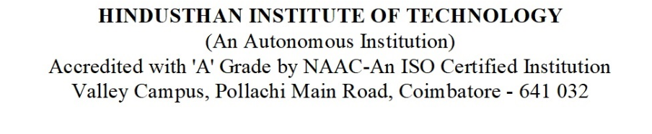

ACKNOWLEDGEMENT

I would like to extend my sincere gratitude to the Satish Dhawan Space Centre - SHAR (SDSC SHAR), ISRO, for providing me with the invaluable opportunity to work on the project "MULTI-VEHICLE CRYOGENIC GROUND SUPPORT SYSTEM FOR LAUNCH OPERATIONS”

I express my deepest appreciation to N. Sreekanth, GeneralManager, Cryogenic Processing System (CPS), Liquid Propellant Storage & Servicing Facilities (LSSF)SDSC-SHAR, ISRO, for his insightful Supervision and constant encouragement throughout this project. His expertise and valuable suggestions have been instrumental in shaping my understanding of cryogenic propellant behavior and heat transfer mechanisms.

I would also like to extend my gratitude to this internship project was carried out under guidance the of POLAKI RAVI KUMAR, Scientist/Engineer, Liquid Propellant Storage & Servicing Facility (LSSF), SDSC SHAR, ISRO

I would also like to extend my gratitude to the entire LSSF department for their support & shared knowledge which greatly contributed to the successful completion of this project. Their assistance has been invaluable in broadening my perspective on cryogenic propellant systems and related thermal management challenges.
I am profoundly grateful to Dr CNATARAJAN, PRINCIPAL of HINDUSTHAN INTITUDE OF TECHNOLOGY for permitting me to undertake this Internship project at such a prestigious organization. Her unwavering support has been a significant pillar in my academic and professional journey.
I also extend my heartfelt thanks to Dr.Thirumalai, Head of the Department of BE Aeronautical Engineering, Hindusthan Institute Of Technology for his continuous guidance, encouragement, and mentorship throughout this journey. His support has been instrumental in enhancing my knowledge and refining my technical skills.

Lastly, I express my sincere gratitude to my institution, faculty members, and mentors for their continuous encouragement and motivation, which have played a crucial role in shaping my academic and professional aspirations.

BONAFIDE CERTIFICATE
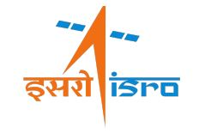

This is to certify that MR. DHANANSAI US [ No. HRD/ STU/I/PRJ2025552] a student of B.E in Aeronautical Engineering at Hindusthan Institute of technology has successfully completed her internship project titled "MULTI-VEHICLE CRYOGENIC GROUND SUPPORT SYSTEM FOR LAUNCH OPERATIONS " at Satish Dhawan Space Centre - SHAR (SDSC SHAR), ISRO.

This internship project was carried out under the supervision of N.SREEKANTH, General Manager,Cryogenic Processing System (Cps), Liquid Propellant Storage & Servicing Facility (LSSF), SDSC SHAR, ISRO as part of her academic curriculum for partial fulfillment of the requirements for the degree of BEin Aeronautical Engineering.

And also,this internship project was carried out under guidance the of POLAKI RAVI KUMAR, Scientist/Engineer, Liquid Propellant Storage & Servicing Facility (LSSF), SDSC SHAR, ISRO

We certify that this work is authentic, carried out independently by he, and has not been submitted elsewhere for the award of any other degree.

Signature of Project Supervisor
N. SREEKANTH
General Manager,
LSSF, SDSC-SHAR,
ISRO

DECLARATION

I, Dhanansai US, a student of B.E in Aeronautical Engineering at Hindusthan Institute of Technology, hereby declare that the internship project report titled "MULTI-VEHICLE CRYOGENIC GROUND SUPPORT SYSTEM FOR LAUNCH OPERATIONS " is an original work carried out by me at Satish Dhawan Space Centre - SHAR (SDSC SHAR), ISRO as a part of my project Internship.

I confirm that this report has not been submitted previously, either in part or full, for the award of any other degree or diploma at this or any other institution & has been completed with integrity under the guidance of POLAKI RAVI KUMAR, Scientist/Engineer, Liquid Propellant Storage & Servicing Facility (LSSF), SDSC SHAR, ISRO

Date:
Place:

Signature:
Dhanansai US
BE in Aeronautical Engineering
Hindusthan Institute of Technology.

ABSTRACT

The present work introduces a computational framework for automated interpretation and performance validation of cryogenic ground support subsystems associated with launch vehicle operations under Indian Space Research Organisation infrastructure. The system enables structured acquisition, temporal synchronization, and analytical reconstruction of cryogenic telemetry generated during pre-launch fueling and post-separation phases.
The framework performs automated extraction of accumulator charging characteristics, reconstruction of charging and discharging sequences, evaluation of cryogenic arm retraction behaviour, and visualization of pressure dynamics for multiple launch vehicle configurations including GSLV and LVM3. The architecture incorporates countdown-referenced temporal alignment, event-driven telemetry correlation, and structured engineering report generation.
The developed system significantly reduces manual interpretation of high-frequency telemetry data by enabling deterministic subsystem evaluation, enhanced diagnostic reliability, and systematic performance validation of cryogenic ground infrastructure.
INDEX

OUTLINE
Chapter No. | Contents | Page No.
01 | ORGANISATION PROFILE  - Indian Space Research Organisation (ISRO)  - Satish Dhawan Space Centre (SDSC) – SHAR  1.2.1 History  1.2.2 Panoramic view of SDSC-SHAR Sriharikota  1.2.3 First Launch Pad  1.2.4Second Launch Pad  1.3 Liquid Propellant Storage And Servicing Facilities | 1 to 6
02 | INTRODUCTION  2.1 About Rocket  2.2 Rocket Working  2.3 Launchers  2.4 Small Satellite Launch Vehicle  2.5 Energy Efficiency  2.6 Purpose  2.7 Types of Propellant  2.7.1 Solid Propellant  2.7.2 Liquid Propellant | 7 to 13
03 | Cryogenic Propellant  3.1 Why Cryogenic  3.2 Cryogenic Propellant  3.3 Cryogenic Propellant test | 14 to 16
04 | CRYOGENIC SYSTEM  4.1 Applications to Cryogenics  4.2 Boiling Point of Common Cryogenic Gases  4.3 Features of Cryogenic System  4.4 Cryogenic System use in ISRO  4.5Rocket Engine Cryogenic Stage Combustion Process  4.6Configuration of Cryogenic Engine  4.7 Components of a Cryogenic Engine | 17 to 23
05 | PROJECT INTRODUCTION  5.1 Introduction  5.2 Dataset | 24 to 46
06 | METHODOLOGY AND SYSTEM DESIGN  6.1 Methodology  6.1 System Logic And Data Interpretation Framework  6.3 System Architecture Diagram | 27 to 35
07 | IMPLEMENTATION AND RESULTS  7.1 Implementation  7.2 Results and Discussion | 36 to 37
08 | OUTPUT SCREENSHOTS | 37 to 43
10 | CONCLUSION & FUTURE SCOPE | 44

CHAPTER 1
ORGANISATION PROFILE

1.1 INDIAN SPACE RESEARCH ORGANISATION (ISRO)
The Indian Space Program was formally initiated in 1972 by the Government of India with a view to provide impetus for the development and application of Space technology and Space Sciences for peaceful applications and socio-economic benefit of the nation. The primary objective of the program is to establish and provide operational space services in a self-reliant manner.
ISRO is a spearhead in India’s space adventures for space innovations. A separate department was founded and named as Department of Space (DOS). Under the policy standardized by the DOS, several sub-organizations have been founded and working on the intent and making India as a leader in space technology. The National Space Program was formally organized in June 1972 with the setting up of Space Commission, Department of Space and Indian Space Research Organization to promote the development and application of Space Technology and Space Sciences for the socio-economic benefit of the nation. ISRO was the result of vision of great Scientists like Dr. Vikram Sarabhai and Prof. Satish Dhawan.

1.2 SATISH DHAWAN SPACE CENTRE (SDSC) - SHAR
Satish Dhawan Space Centre, SHAR is located in Sriharikota, SPSR Nellore District of Andhra Pradesh. It is located on the East Coast of India at around 80 Km north of Chennai, and is the launch station for all satellite launch vehicles to take advantage of the earth’s rotation and other factor affecting the flight of a launch vehicle.
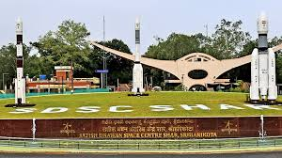
FIG 1.1SDSC-SHAR
1.2.1History
- Sriharikota island was chosen in 1969 for a satellite launching station. It is located 80 km (50 mi) north of Chennai. The centre became operational on 9 October 1971 when an RH-125 sounding rocket was launched. The first attempted launch of an orbital satellite, Rohini 1A aboard a Satellite Launch Vehicle, took place on 10 August 1979, but due to a failure in thrust vectoring of the rocket's second stage, the satellite's orbit decayed on 19 August 1979. SHAR was named as 'Satish Dhawan Space Centre SHAR' (SDSC), on 5 September 2002, in memory of Satish Dhawan, former chairman of the ISRO.
- The SHAR facility now consists of two launch pads, with the second built in 2005. The second launch pad was used for launches beginning in 2005 and is a universal launch pad, accommodating all of the launch vehicles used by ISRO. The two launch pads will allow multiple launches in a single year, which was not possible earlier. India's lunar orbiter Chandrayaan-1 launched from the centre at 6:22 AM IST on 22 October 2008. India's first Mars orbiter Mangalyaan was launched from the centre on 5 November 2013, which was successfully placed into Mars orbit on 24 September 2014.
- Initially under Indian Human Spaceflight Programme existing launch facilities will be augmented to meet the target of launching a crewed spacecraft called Gaganyaan.
- Satish Dhawan Space Centre (SDSC-SHAR) is located in Sriharikota, a spindle-shaped barrier island on the east coast of Andhra Pradesh. Features like a good launch azimuth corridor for various missions, nearness to the equator (benefiting eastward launches), and large uninhabited area for a safety zone make it an ideal spaceport.
- SHAR covers a total area of about 145 km² (56 sq. mi) with a coastal length of 27 km (17 mi). Prior to its acquisition for ISRO by the Government of India, it was a firewood plantation of Eucalyptus and Casuarina trees. This island is affected by both south-westerly and north-easterly monsoons, but heavy rains come only in October and November. Thus many clear days are available for out-door static tests and launchings.
- SHAR is linked to Sullurupeta by a road across Pulicat Lake. Sullurupeta has connectivity with other parts of India by Indian Railways and is on a National Highway 16 (India) that connects it to Chennai and Kolkata.
- Originally known as the Sriharikota Range (SHAR) and later named after Satish Dhawan. It is India's primary orbital launch site to this day. First flight-test of 'Rohini-125', a small sounding rocket which took place on 9 October 1971 was the first rocket launch from SHAR. Since then technical, logistic and administrative infrastructure have been enhanced. Together with the northerly Balasore Rocket Launching Station, the facilities are operated under the ISRO Range Complex (IREX) headquartered at SHAR. Satellite Launch Vehicle (SLV). The range became operational when three Rohini 125 sounding rockets were launched on 9 and 10 October 1971. Previously, India used Thumba Equatorial Rocket Launching Station (TERLS), at Thiruvananthapuram, on the south-western coast of India, to launch sounding rockets.
1.2.2 Panoramic view of SDSC-SHAR Sriharikota
- The first test launch of the complete SLV-3 rocket occurred in August 1979 but it was only partially successful following a malfunction in the second-stage guidance system. SHAR facilities worked satisfactorily during the SLV-3 preparation and launch. On 18 July 1980 the SLV-3 successfully launched India's third satellite. Out of the four SLV launches from SHAR, two were successful.

Augmented Satellite Launch Vehicle (ASLV)
The ASLV orbital launcher was integrated vertically, beginning with motor and subassembly preparations in the Vehicle Integration Building (VIB) and completed on the pad within the 40 m tall Mobile Service Structure. The first ASLV launch from SHAR took place in 1987 and resulted in a failure. Eventually, out the four ASLV launches from 1987 to 1994, only one was successful.

Polar Satellite Launch Vehicle (PSLV)
The Polar Satellite Launch Vehicle launch complex was commissioned during 1990. It has a 3,450 tonne, 76.5 m high Mobile Service Tower (MST) which provides the SP-3 payload clean room. The solid propellant motors for the PSLV are processed by SHAR, which also carries out launch operations. The first launch of the PSLV took place on 20 September 1993.

Geosynchronous Satellite Launch Vehicle (GSLV)
The first launch of India's Geosynchronous Satellite Launch Vehicle (GSLV) was successfully completed on 18 April 2001. GSLV, with its own cryogenic upper stage, has enabled the launch of communications satellites of the class up to 2 tonnes. The next variant of GSLV is GSLV Mk III with its own cryogenic high-thrust engine and stage capable of launching communications satellites of the 4-ton class.

1.2.3 First Launch Pad
- PSLV C40 in XL configuration before launch at First Launch Pad.
- The First Launch Pad, located at 13.73333902688702°N 80.23466545201548°E, began operation in 1993. It is currently used to launch the Polar Satellite Launch Vehicle, and formerly used by the Geosynchronous Satellite Launch Vehicle. It is one of two operational orbital launch pads at the site, the other being the Second Launch Pad, which opened in 2005. The first launch from this pad occurred on 20 September 1993, and was the maiden flight of the Polar Satellite Launch Vehicle carrying the IRS-1E satellite. The maiden flight of the Small Satellite Launch Vehicle also occurred from this pad on 7 August 2022.
- The First Launch Pad is undergoing major expansion with PIF (PSLV Integration Facilities) project worth ₹475 crore (US$59 million) . Once complete, the first launch pad is expected to cater to around 15 launches per year.
- PSLV-C58 XPoSat Launch on 1 January 2024, from First launch pad.
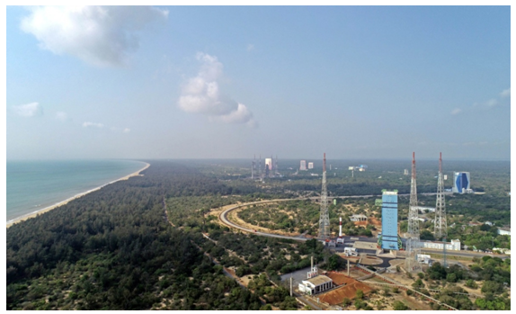
Fig.1.2 First launch pad

1.2.4 Second Launch Pad
The fully integrated GSLV-F05 carrying INSAT-3DR approaching.
- The Second Launch Pad, located at 13.719944631849723°N 80.23048095346692°E, was designed, supplied, erected and commissioned by MECON Limited, a Government of Indian Enterprise, located at Ranchi (Jharkhand, India) during the period March 1999 to December 2003. It cost about ₹400 crore (equivalent to ₹14 billion or US$170 million in 2023) at that time.
- The second launch pad with associated facilities was built in 2005 and became operational on 5 May with the launching of PSLV-C6. MECON's sub-contractors for this project including Inox India, HEC, Tata Growth, Gendered Boyce, Simplex, Nagarjuna Construction, Steel age, etc. The other Launch Pad being the First Launch Pad. It is used by Polar Satellite Launch Vehicle, Geosynchronous Satellite Launch Vehicle, LVM3 and is intended for India's first crewed space mission.
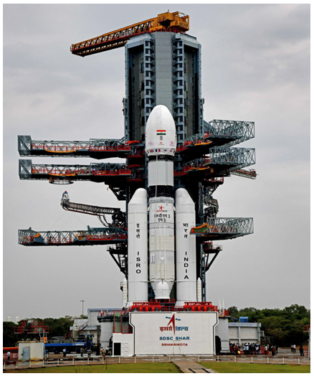

Fig. 1.3 Second Launch pad

- The first launch from the pad occurred on 5 May 2005, and was of a Polar Satellite Launch Vehicle carrying the CARTOSAT-1 and HAMSAT satellites. India's 1st Moon Mission, Chandrayaan-1 was launched from this launch pad on 22 October 2008. Its follow-up missions were also launched from this launch pad, where Chandrayaan-2 was launched on 22 July 2019 and Chandrayaan-3 was launched on 14 July 2023.
- In November 2019, ISRO released tenders for augmentation of SLP for Gaganyaan project.
- In 12 Aug 2021, GSLV F10
- In 29 May 2023, GSLV F12
- In 17 February 20204, INSAT-3DS meteorological Satellite launched in GSLV F14 vehicle.

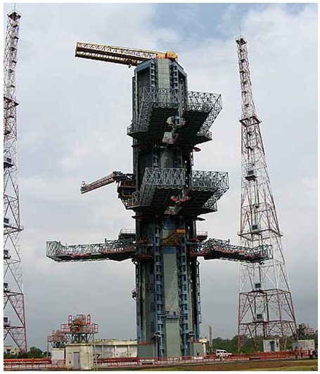
Fig 1.4 Umbilical Tower

1.3 LIQUID PROPELLANT STORAGE AND SERVICING FACILITIES
LSSF Entity is primarily responsible for Propellant and gas servicing of liquid and cryo stages of PSLV, GSLV MkII and GSLV MkIII during countdown for all the launch vehicles. The entity will be conceiving, designing and realizing the state of the art storage & servicing facilities for the earth storable, cryogenic propellants and the service fluids for the ISRO’s launch vehicles servicing. The process and instrumentation facilities are spread around the launch pads and the filling control system is located at Zero point.
LSSF consists of more than 25 facilities at various locations for propellant storage and servicing and the major systems are as follows:
- Earth Storable Propellant servicing systems (ESPS)
- Cryo propellant systems (CPS)
- Compressed Gas Systems (CGS)
- Instrumentation & Control Systems (ICS)
CHAPTER 2
INTRODUCTION
2.1 ABOUT ROCKET
A rocket is a vehicle that uses jet propulsion to accelerate without using the surrounding air. A rocket engine produces thrust by reaction to exhaust expelled at high speed. Rocket engines work entirely from propellant carried within the vehicle; therefore, a rocket can fly in the vacuum of space.

2.2. ROCKET WORKING
The principle of rocket propulsion depends on the following two laws: -

- Newton’s Third Law of Motion
- Law of conservation of momentum

The motion of a rocket is an interesting application of Newton’s third law of motion& momentum principle. The rocket expels a jet of hot gases from its tail. This is say, anaction force. The jet of hot gases exerts a force on the rocket, propelling it forward; this is thereaction force. From the momentum point of view, the hot gases acquire momentum in thebackward direction & the rocket acquires an equal amount of momentum in the forwarddirection. The simplest example to understand the propulsion of rockets is consideration of aballoon.A balloon shooting forward (when the mouth of the balloon filled with air is released)and a rocket hurtling into space are propelled by similar forces. The air in a closed balloonexerts a uniform outward force. But when air rushes out of its neck (similar to exhaust gasesleaving rockets) disturbs this equilibrium. Thus, an equal and opposite force is exerted on thesurface opposite to the neck. This drives the balloon forward.The propellants used in rocket upon burning produces large amount of gas, which areallowed to pass through nozzle. On passing through the nozzle, high pressure is generated i.e.gas comes out with high pressure. Now to increase the thrust, one basic property is usedwhile designing the nozzle. The neck of the nozzle is kept very small as compared to thebody of the rocket. So the pressure of the gas increases and so does the velocity. Thus, highthrust is achieved The acceleration of the gases through the engine exerts force, or thrust, on the combustion chamber and nozzle. The shape of the nozzle also generates force by directing the exhaust gas along the axis of the rocket.

2.3. LAUNCHERS:
2.3.1. SLV
- Satellite launch vehicle SLV - 3 was India’s first experimental satellite launch vehicle, which was an all solid 4 stage 17 tonnes with a height of 22m and capable of placing 40 KG class in low at orbit LEO.
- SLV3 was successfully launched on July 18 1980 from SHAR, when Rohini satellite, RS1, was placed in orbit there by making India the sixth member of an exclusive club of space faring nation.
2.3.2. ASLV
- The Augmented satellite launch vehicle (ASLV) Programme was designed to augment the payload capacity to 150 kg, thrice that of SLV-3 for low earth orbits LEO.
- ASLV Proved to be a low-cost intermediate vehicle to demonstrate and validates critical technologies that would be needed for the future launch vehicles like strap- on technology, inertial navigation, bulbous heat shield, vertical integration and close loop guidance.
- The first development fight to place of March 24, 1987 and the second of July 13, 1988. The third development flight ASLV- D3 trade was successfully launched and may 20, 1992.
2.3.3. PSLV
- Polar satellite launching vehicle is the generation launch vehicle of India it is the first Indian launch vehicle to be with a quit stage after reads a first successful launch in October 1994 PSLV emerge as the reliable and versatile workhorse launch vehicle of India with 39 consecutively successful missions by June 2017. During 1994- 2017 period, the vehicle has launched 48 Indian satellite and 209 satellite for customer from abroad.
- Besides the vehicle successfully launched two spacecraft Chandrayaan-1in 2008 and Mars orbits spacecraft in 2013 that later travelled to Moon and Mars respectively.
2.3.4. GSLV
- Geosynchronous satellite launch vehicle mark II (GSLV MK2) is the largest launched vehicle developed by India which is currently in operation these four generations launch vehicle is a three-stage vehicle with 4 liquid strap-ons.
- The indigenously developed cryogenic upper stage CUS which forms the third stage of GSLV MKII from January 2014 the vehicle has achieved for consecutive successes.
2.3.5. GSLV MK3
- GSLV MKIII chosen to launch chandrayaan -2 spacecraft is a three-stage heavy lift launch vehicle developed by ISRO the vehicle has two solid strap-ons, a core liquid booster and a cryogenic upper stage.
- GSLV MK3 is designed to carry 4-ton class of satellites into geosynchronous transfer orbit GTO or about 10 tons into low earth orbit which is about twice the capable the of GSLV-M K2.

2.3.6. RLV-TD
- Reusable launch vehicle technology demonstrator RLV-TD is one of the most technological challenging endeavours of ISRO towards developing essential technology for a fully reusable launch vehicle to enable low-cost access to space.
- RLV-TD was successfully flight tested on May 23 2016 from SDSC SHAR.
2.3.7. SCRAMJET ENGINE-TD
- The first experimental mission of ISRO’S scramjet engine towards the realisation of an Air breathing propulsion system was successfully conducted on August 28 2016 SHAR Sriharikota.
- The scramjet engine designed by ISRO uses hydrogen as fuel and the oxygen from the atmospheric air as the oxidizer.
2.4 SMALL SATELLITE LAUNCH VEHICLE:
- The SSLV is the smallest vehicle weighing only 10 tons.
- It would take only 72 hours to integrate, unlike the 70 days taken for launch vehicles like polar satellite launch vehicle (PSLV) or geosynchronous satellite launch vehicle.
- The Indian national committee for space research (INCOSPAR) was established by Jawaharlal Nehru in 1962 under the department of atomic energy.
- Eminent scientist Dr Vikram Sarabhai had a big role in this development and he understood the need of space research and he was convenience of the role it helping a nation development.

- INCOSPAR set up the Thumba equatorial rocket launching station (TERLS) at Thumba, near Thiruvananthapuram at India's Southern trip, TERLS is a spaceport used to launch rockets.
- The INCOSPAR became ISRO in 1969. The Department of space was created in 1972 and ISRO become a part of it and the remains so till date. The space department reports directly to the prime minister of India. ISRO had many facilities each dedicated to a specialized field of study in space.
- Satish Dhawan Space Centre – SDSC (formerly Sriharikota Range – SHAR), is the primary spaceport of the Indian Space Research Organisation (ISRO), located in Sriharikota, Andhra Pradesh.
- The Centre currently has two functioning launch pads used for launching Sounding rockets, Polar satellites and Geosynchronous satellites. India's Lunar exploration probes Chandrayaan-1, Chandrayaan-2, Chandrayaan-3 , Mars Orbiter Mission, solar research mission Aditya-L1 and space observatory XPoSat were also launched in SDSC.
- Originally called Sriharikota Range (SHAR), the centre was renamed on 5 September 2002 as a tribute to ISRO's former chairman Satish Dhawan with retaining its original acronym and is referred as SDSC-SHAR.
2.5 ENERGY EFFICIENCY
Rocket engines are up to 60% efficient. Efficiency is a measure of how much of the chemical energy in a fuel source is converted to kinetic energy. The efficiency of rocket engines compares favourably with the efficiency which is displayed by motor vehicles since motor vehicles rarely exceed 50% efficiency.
2.6 PURPOSE

Rockets deliver satellites to space where they can begin towe wouldn't be able to use our cell phones, find out the weather forecast, navigate with Global Positioning System (GPS), or explore our solar system
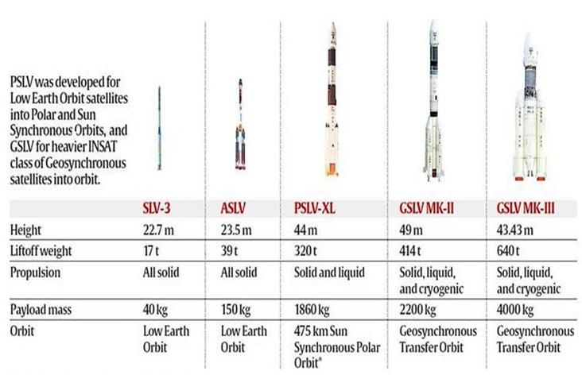

Fig. 2.1. Evolution Of Rocket

2.7 TYPES OF PROPELLANT

1. Solid Propellants 2. Liquid Propellants 3.Cryogenic Propellants

2.7.1 Solid Propellant

In ballistics and pyrotechnics, a propellant is a generic name for chemicals used for propelling projectiles from guns and other firearms. Propellants are usually made from low explosive materials, but may include high explosive chemical ingredients that are diluted and burned in a controlled way (deflagration) rather than detonation. The controlled burning of the propellant composition usually produces thrust by gas pressure and can accelerate a projectile, rocket, or other vehicle. In this sense, common or well known propellants include, for firearms, artillery and solid propellant rockets:
- Composite propellants made from a solid oxidizer such as ammonium perchlorate or ammonium nitrate, a rubber such as HTPB, or PBAN (may be replaced by energetic polymers such as polyglycidyl nitrate or polyvinyl nitrate for extra energy) , optional high explosive fuels (again, for extra energy) such as RDX or nitro-glycerine, and usually a powdered metal fuel such as aluminium.
- Some amateur propellants use potassium nitrate, combined with sugar, epoxy, or other fuels / binder compounds.
- Potassium perchlorate has been used as an oxidizer, paired with asphalt, epoxy, and other binders.
- Gun propellants, such as:
- Gun powder (black powder)
- Nitrocellulose-based powders
- Cordite
- Ballistite
- Smokeless powders

1). Composition

There are four different types of solid propellant compositions:

- Single Based Propellant: A single based propellant has nitrocellulose as its chief explosive’s ingredient. Stabilizers and other additives are used to control the chemical stability and enhance the propellant’s properties.
- Double Based Propellant: Double based propellants consist of nitrocellulose with nitro-glycerine or other liquid organic nitrate explosives added. Stabilizers and other additives are used also. Nitro-glycerine reduces smoke and increases the energy output. Double based propellants are used in small arms, cannons, mortars and rockets.
- Triple Based Propellant: Triple based propellants consist of nitrocellulose, nitroquanidine, nitro-glycerine or other liquid organic nitrate explosives. Triple based propellants are used in cannons.

2)Composite:

Composites contain no nitrocellulose, nitro-glycerine, nitro-quanidine or any other organic nitrate. Composites usually consist of a fuel such as metallic aluminium, a binder such as synthetic rubber, and an oxidizer such as ammonium perchlorate. Composite propellants are used in large rocket motors.

3). Grain:

Propellants are used in forms called grains. A grain is any individual particle of propellant regardless of the size or shape. The shape and size of a propellant grain determines the burn time, amount of gas and rate produced from the burning propellant and consequently thrust vs time profile.

There are three types of burns that can be achieved with different grains.
- Progressive Burn: Usually, a grain with multiple perforations or a star cut in the centre providing a lot of surface area.
- Regressive Burn: Usually, a solid grain in the shape of a cylinder or sphere.
- Neutral Burn: Usually a single perforation; as outside surface decreases the inside surface increases at the same rate.

2.7.2 Liquid Propellant

Common propellant combinations used for liquid propellant rockets include:

Classification of liquid propellants
- Earth Storable Propellants

- RFNA and Unsymmetrical dimethyl hydrazine (UDMH)
- Dinitrogen tetroxide and UDMH, MMH and/or hydrazine
- Nitrogen tetroxide (N₂O₄)
- Red fuming nitric acid (RFNA) and kerosene or RP-1
- Hydrogen peroxide and alcohol or RP-1
- Chlorine pentafluoride and hydrazine

- Cryogenic Propellants

- Liquid oxygen and liquid hydrogen
- Liquid oxygen and Liquid helium
- Liquid oxygen and Ethanol
- Liquid Nitrogen

3. Semi Cryogenic Propellants
- Liquid oxygen and kerosene or RP-1

Common monopropellant used for liquid rocket engines include:
- Hydrogen peroxide ● Hydrazine ● Red fuming nitric acid (RFNA)

CHAPTER - 3

CRYOGENIC PROPELLANT

3.1 WHY CRYOGENICS
A Cryogenic rocket stage is more efficient and provides more thrust for every kilogram of propellant it burns compared to solid and earth-storable liquid propellant rocket stages. Specific impulse (a measure of the efficiency) achievable with cryogenic propellants (liquid Hydrogen and liquid Oxygen) is much higher compared to earth storable liquid and solid propellants, giving it a substantial payload advantage. However, cryogenic stage is technically a very complex system compared to solid or earth-storable liquid propellant stages due to its use of propellants at extremely low temperatures and the associated thermal and structural problems. Oxygen liquefies at -183 deg C and Hydrogen at -253 deg C. The propellants, at these low temperatures are to be pumped using turbo pumps running at around 40,000 rpm. It also entails complex ground support systems like propellant storage and filling systems, cryo engine and stage test facilities, transportation and handling of cryo fluids and related safety aspects.
3.2 CRYOGENIC PROPELLANT
Cryogenics originated form two Greek words “Kryos” means cold (or) freezing and “Genics” means produce (or) born. Cryogenics is the study of very low temperatures (or) the production of the same. Liquefied gases like liquid nitrogen and liquid oxygen are used in many cryogenic applications. Liquid nitrogen is the most commonly used element in cryogenics and is legally purchasable around the world. Liquid helium is also commonly used and allows for the lowest temperatures to be reached. These gases can be stored on large tanks called "Dewar tanks, named after James Dewar, who first liquefied hydrogen, or in giant tanks used for commercial applications.Cryogenic rocket engines are designed in such a way that the fuels remain liquid fuels can be held at “cryogenic temperature” The components are also cooled so that the fuel doesn’t get boiled off. The thrust for the rocket comes from the rapid expansion of the liquid fuels & the energy needed to heat the fuel comes from burning them once they are gases. The cryogenic rockets are the highest performance engines but the only disadvantage while designing these engines is that they are bulky and require heavy installation for propellants. The Space Shuttle's main engines used for liftoff are cryogenic engines. The Shuttle's smaller thrusters for orbital manoeuvrings use non-cryogenic hypergolic fuels, which are compact and are stored at warm temperatures. Currently, only the United States, Russia, China, France, Japan and India have mastered cryogenic rocket technology. The cryogenic engine gets its name from the extraordinarily bloodless temperature at which liquid nitrogen is stored. Air transferring across the vehicle is used to warmness liquid nitrogen to a boil. once it boils, it turns to gas inside the identical manner that heated water paperwork steam in a steam engine. A rocket just like the Ariane 5 makes use of oxygen and hydrogen, both saved as a cryogenic liquid, to provide its power. The liquid nitrogen, stored at 320 degrees Fahrenheit, is vaporized with the aid of the heat exchanger. Nitrogen gasoline fashioned inside the heat exchanger expands to approximately seven hundred instances the extent of its liquid form. This distinctly pressurized gasoline is then fed to the expander, in which the force of the nitrogen gasoline is converted into mechanical energy.Cryogenic rocket stages are more efficient than solid and earth-storable liquid propellant rocket stages, and provide more thrust for every kilogram of propellant burned. Cryogenic rocket engines use liquid oxygen and liquid hydrogen as oxidizers and fuel, which are clean and non-pollutant fuels.
ISRO's Cryogenic Upper Stage Project (CUSP) envisaged the design and development of the indigenous Cryogenic Upper Stage to replace the stage procured from Russia and used in GSLV flights. The main engine and two smaller steering engines of CUS together develop a nominal thrust of 73.55 kN in vacuum. During the flight, CUS fires for a nominal duration of 720 seconds.
Liquid Oxygen (LOX) and Liquid Hydrogen (LH2) from the respective tanks are fed by individual booster pumps to the main turbo pump to ensure a high flow rate of propellants into the combustion chamber. Thrust control and mixture ratio control are achieved by two independent regulators. Two gimballed steering engines provide for control of the stage during its thrusting phase. GSLV-D5/GSAT-14 Indigenous Cryogenic Engine and Stage GSAT-14 GSLV-D5. The cryogenic upper stage of the LVM3 M4 launch vehicle made an uncontrolled re-entry into the Earth’s atmosphere, around 14:42 IST today. The probable impact point was predicted over the North Pacific Ocean. The final ground track did not pass over India. This rocket body (NORAD id 57321) was part of the vehicle that successfully injected the Chandrayaan-3 spacecraft into the intended orbit of 133 km x 35823 km with a 21.3º inclination on July 14, 2023.
The re-entry of the rocket body took place within 124 days of its launch. The post-mission orbital lifetime of the LVM3 M4 Cryogenic upper Stage is, thus, fully compliant with the “25-year rule” for LEO (Low Earth Orbit) objects as recommended by the Inter-Agency Space Debris Coordination Committee (IADC).
Post Chandrayaan-3 injection, the upper stage had also undergone “passivation” to remove all residual propellant and energy sources to minimise the risks of accidental explosions as per the space debris mitigation guidelines prescribed by the United Nations and IADC. Passivation and post-mission disposal of this rocket body in adherence to the internationally accepted guidelines once again reaffirms India’s commitment to preserve the long-term sustainability of outer space activities.

3.3 CRYOGENIC PROPELLANT TEST
3.3.1 Explosive Testing
The tanks filled with two propellants are separated by glass and the fuel and oxidizer are mixed by triggering a window break mechanism. Check valves and relief valves are installed to prevent backflow and accidental pressure increases. A break-away coupler is used to disconnect the fill and vent pipeline from the test area before activating the best sequence.
3.3.2 Cryogenic Recirculation Test
An electrical driven recirculation pump is used to understand tank-to-tank recirculation in cryogenic orbital propulsion systems. The pump head performance is similar in both water and liquid nitrogen operations.
3.3.3 Hot Test
The engine is operated in the nominal and 13% uprated thrust regimes for a planned duration of 200 seconds. All the propulsion parameters during the test are found satisfactory and closely match with predictions.

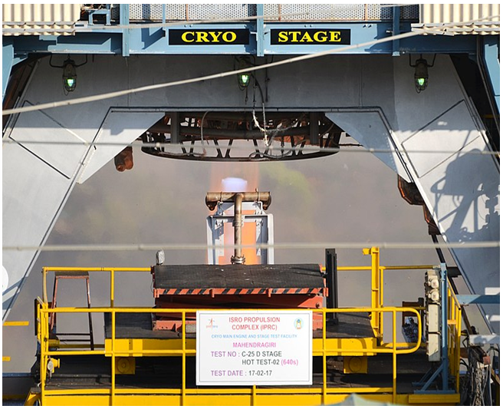
Fig.3.1 Cryogenic stage (C25) hot test
CHAPTER - 4
CRYOGENIC SYSTEM

Cryogenics plays a pivotal role in the field of Space Science & Rocket propulsion. It is the study of the production and behavior of materials at extremely low temperatures typically below -150 degree C or -238-degree F. These low temperatures can drastically change the physical properties of materials. Some cryogenic gases include Helium,Hydrogen, Nitrogen, Oxygen & Neon.

4.1 APPLICATION OF CRYOGENICS

- In Propulsive systems, Liquid Oxygen is used as an oxidiser& Liquid hydrogen is used as a fuel are used in rockets.

- In Medicine, cryosurgery is done by freezing the aberrant tissue such as tumours& warts to eradicate them.

- In Preserving stuff, Cryopreservation is done to preserve blood, reproductive cells & tissues are kept at cryogenic temperature.

- Creation & functioning of superconducting materials in MRI & Particle accelerator have zero electrical resistance at cryogenic temperature.

- For Manufacturing & transportation of Liquid Nitrogen Gas cryogenic technology also came into consideration.

4.2 BOILING POINT OF COMMON CRYOGENIC GASES

Gas | Boiling Point (K) | Boiling Point (°C) | Boiling Point (°F)
Helium | 4.22 | -268.93 | -452.08
Hydrogen | 20.28 | -252.87 | -423.17
Neon | 27.1 | -246.05 | -410.89
Nitrogen | 77.36 | -195.79 | -320.42
Oxygen | 90.19 | -182.96 | -297.33
Argon | 87.3 | -185.85 | -302.53
Methane | 111.7 | -161.45 | -258.61

Table 4.1 Boiling Point of Common Cryogenic Gases

4.3 FEATURES OF CRYOGENIC SYSTEM
4.3.1. Cryogenic Liquification

Gases are stored in their liquid form. Common gases used in cryogenic systems include nitrogen (N₂), oxygen (O₂), argon (Ar), hydrogen (H₂), and helium (He).
Various methods are used for liquefaction of gas such as Joule Thompsan, Claude cycle & Linde Cycle.

4.3.2. Cryogenic Propellant Storage & Handling

4.3.2.1 Cryogenic Tanks

After the liquefaction of gas, the cryo fluid is kept in a cryo storage vessel. These storage vessels are highly insulated to maintain their cryo temperature & to prevent boil off vaporization. They typically use expanded foam or Multi Layer Insulation to minimize heat ingress.

4.3.2.2 Cryogenic Pressure Control System

Cryogenic Pressure control systems are stored under pressure or in vacuum to maintain their liquid state. Cryogenic storage tanks are equipped with pressure relief valves & venting systems to regulate internal pressure.

4.3.2.3 Tank Material

Tank materials are made up of materials that can withstand the extremely low temperature without becoming brittle by using special alloys & stainless steel.

4.3.3. Cryogenic Pumps & Compressor

4.3.3.1 Cryogenic Pumps

Cryogenic pumps are used to transfer the liquid propellant from storage tanks to rocket engines. These pumps are needed to operate at low temperature & maintain efficient flow rates

4.3.3.2 Cryogenic Compressor

Compressors are used to increase the pressure of the gas during the liquefaction process, which is essential for achieving the desired low temperature. Cryo gases are drawn into the compressor at a relatively low pressure and then compressed to a much higher pressure.
Heat exchangers are used to manage the temperature of cryogenic fluids and gases within the system. They allow for efficient heat transfer from one fluid to another.
4.3.3.3 Insulation System

Insulation systems prevent fluid from evaporating or warming up during storage due to atmospheric temperature.
4.3.3.4. Cryogenic Heat Exchanger

Heat exchangers are used to manage the temperature of cryogenic fluids and gases within the system. They allow for efficient heat transfer from one fluid to another, often cooling gases down to liquid form or warming them up during the vaporization process.

4.3.3.5. Cryogenic Material Treatment

Cryogenic treatment involves exposing materials to extremely low temperatures (below -150°C) to enhance their mechanical properties like durability, strength & performance.
Material then gradually warmed back to room temperature. It should be controlled to avoid thermal stress that could damage the material or experience thermal shock due to rapid temperature change.
4.3.3.6. Cryogenic Control System

- Automation

Modern cryogenic processing systems use automated control systems to monitor and manage the operation of pumps, compressors, tanks, and heat exchangers. Sensors are employed to track temperature, pressure, and flow rates

- Safety Monitoring

Cryogenic systems require continuous monitoring for leaks, over-pressurization, or system failures. Alarms and shutdown mechanisms are in place to ensure the safe operation of the system.

4.3.3.7 Cryogenic Safety Systems

- Pressure Relief Valves

Pressure Relief Valves are critical to prevent over-pressurization in cryogenic tanks, which could lead to system failure or explosion.
- Vent Systems

Cryogenic gases naturally evaporate with respect to time resulting in increase in pressure during boil-off vapourisation. Vent system helps to control pressure by releasing the vapour.

- Thermal Shield
Cryogenic storage tanks require thermal shielding to minimize heat leakage and prevent excessive boil-off of stored cryogenic liquids. Effective thermal shielding ensures efficient long-term storage and transportation of cryogenic fluids.It includes various methods such as vacuum insulation, multi layer insulation, cryocoolers, aerogels, expanded foam.

4.4 CRYOGENIC SYSTEM USE IN ISRO
Features | CE - 7.5 Engine | CE - 20 Engine
Launch Vehicle | GSLV MK II | GSLV MK III
Application | Upper Stage of Mark II | Upper Stage of Mark III
Thrust ( in vacuum) | 75 kN | 186.36 kN
Propellant Combination | LOX + LH2 | LOX + LH2
Cycle Type | Gas Generator | Gas Generator
Specific Impulse ( Isp) | 454 sec | 442 sec
Burn Time | 720 sec | 720 sec
Chamber Pressure | 58 bar | 60 bar
Throttle Control | No | Yes( 60 - 100%)
Thrust Vector Control | No | Yes ( Electro - mechanical Actuators)
Turbo pump | Lower capacity | Higher efficiency, supports high fuel rate.

Table.4.2 : CE- 7.5 Engine VS CE- 20 Engine

4.5 ROCKET ENGINE CRYOGENIC STAGE COMBUSTION PROCESS
The major components of a cryogenic rocket engine are: combustion chamber (thrust chamber), pyrotechnic igniter, fuel injector, fuel cry pumps, oxidizer cry pumps, gas turbine, cryo valves, regulators, the fuel tanks and rocket engine nozzle. In terms of feeding propellants to combustion chamber, cryogenic rocket engines (or generally all liquid- propellant engines) work in either an expander cycle, a gas-generator cycle, a staged combustion cycle, or the simplest pressure-fed cycle. The cry pumps are always turbo pumps powered by a flow of fuel through gas turbines. Looking at this aspect, engines can be differentiated into a main flow or a bypass flow configuration. In the main flow design, all the pumped fuel is fed through the gas turbines, and in the end injected to the combustion chamber. In the bypass configuration, the fuel flow is split; the main part goes directly to the combustion chamber to generate thrust, while only a small amount of the fuel goes to the turbine. Various parts in a cryogenic rocket engine. When the Rocket advances to an optimum altitude the plume boundary equals the diameter of nozzle that means ambient pressure equals exhaust pressure. Therefore, maximum efficiency is achieved i.e. 100% this phase gives full efficiency which is only possible in cryogenic engine.

4.6 CONFIGURATION OF CRYOGENIC ENGINE

Cryogenic propulsion systems using liquid hydrogen and liquid oxygen propellant combination are used in satellite launch vehicles to generate higher specific impulse (ISP) of around 450 - 460 sec.

The Cryogenic Upper Stage engine consists of a main engine and two steering engines capable of developing a nominal thrust of 73.5 kN in vacuum with a specific impulse of 454 s. It works on staged combustion cycle in which the entire gas generated in the pre-combustion chamber is fed into the main thrust chamber after driving the turbine, which eventually results in maximum performance.

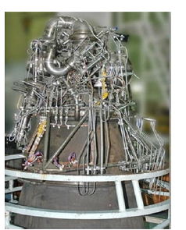
Fig 4.1: Cryogenic Engine
The LOX and LH2 feed systems are chilled down before engine start to the required temperatures. The thrust and mixture ratio regulators are set to a position corresponding to engine's normal working condition. At T0 (start time), high-pressure helium gas is used to drive the fuel booster turbine. LH2 enters the system and evaporates which drives the turbopumps in expander mode. LOX flows through the booster and main pumps. At T0 + 0.5 s, the steering engine igniters are turned on, and LOX enters the steering engines. At T0 + 0.9 s, the main engine igniter is turned on, followed by LOX to the main engine at T0 + 1.4 s, with the pre-burner igniter switched on.

The main engine ignites at T0 + 1.8 s, and the thrust & mixture ratio regulators are adjusted to the nominal working position at T0 + 1.9 s. The engine reaches normal operation. After ensuring proper engine performance, the regulation systems switch to closed-loop & the engine produces thrust, then throttled to nominal at 425 s and shut down after 295 s.
4.7 COMPONENTS OF A CRYOGENIC ENGINE:
- Combustion chamber●Fuel tanks
- Rocket engine nozzle
- Fuel injector
- Pyrotechnic initiator
- Turbo-pumps for fuel and oxidizers
- Cryogenic valves
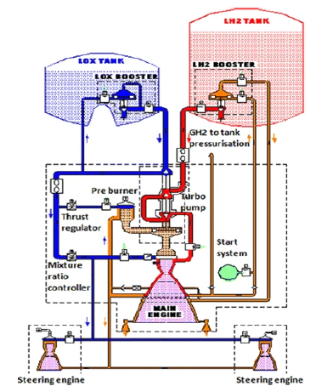
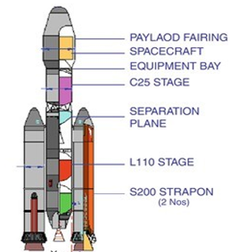
Fig 4.3 Cryogenic EngineDiagram

CHAPTER 5

5.1 INTRODUCTION
Cryogenic ground support systems constitute a critical component of launch vehicle operations, governing propellant transfer, accumulator charging mechanisms, and cryogenic arm actuation processes. These subsystems ensure controlled handling of liquid oxygen and liquid hydrogen under extreme thermal conditions and must exhibit precise operational behaviour to maintain launch readiness.
Traditional evaluation of cryogenic system performance involves manual inspection of extensive telemetry records, resulting in prolonged analysis duration and limited capability for time-synchronized interpretation. The increasing complexity of launch vehicle configurations necessitates automated mechanisms capable of reconstructing subsystem behaviour and validating operational performance.
This project presents an automated analytical framework that reconstructs cryogenic system dynamics through structured telemetry processing. The system performs temporal alignment of multiple datasets, evaluates accumulator charging states, analyzes actuator motion characteristics, and generates structured engineering reports describing subsystem behaviour. The framework supports multiple launch vehicle configurations and provides a scalable approach for systematic cryogenic system validation.

5.2 DATASET
5.2.1 Overview of Data Acquisition Framework
The proposed system operates on mission telemetry datasets representing cryogenic ground support subsystem behaviour for multiple launch vehicle configurations. The datasets consist of high-resolution time-stamped operational measurements capturing thermodynamic, hydraulic, and electromechanical parameters associated with liquid oxygen (LOX) and liquid hydrogen (LH₂) handling infrastructure.
The acquired data streams enable reconstruction of accumulator pressurization dynamics, propellant transfer conditions, actuator behaviour, and cryogenic arm separation sequences during pre-launch and post-launch operational phases.
Each dataset contains synchronized telemetry measurements including:
- time-stamped process variables
- liquid oxygen pressure measurements
- liquid hydrogen pressure measurements
- accumulator charging and discharging timing values
- cryogenic arm boom position measurements
- hydraulic and oil temperature indicators
- pivot valve command and feedback signals
- event-triggered mission sequence parameters
- actuator position feedback data
These datasets form the primary input for subsystem behaviour reconstruction and operational performance evaluation.

5.2.2 Mark-2 (GSLV) Vehicle Datasets
The Mark-2 configuration datasets correspond to cryogenic subsystem telemetry associated with GSLV-class launch vehicle operations.
Dataset 1
MK2_F16LaunchPresata30072025
Contains high-frequency pressure and subsystem state measurements during launch preparation operations.
Dataset 2
MK2_Sim_Times_05022026
Contains programmable logic controller timing signals representing accumulator charging, discharging, and mission event transitions.
Dataset 3
MK2_F16Launch25mSec Data_30072025
Contains millisecond-resolution cryogenic arm motion and actuator position measurements.

5.2.3 Mark-3 (LVM3) Vehicle Datasets
The Mark-3 configuration datasets correspond to telemetry generated during LVM3 cryogenic subsystem operations and provide extended measurement resolution and additional event channels.
Dataset 1
MK3_M6 LaunchPressureData_24122025
Contains cryogenic pressure and subsystem state measurements.
Dataset 2
MK3_Sim_Times_0502026
Contains programmable logic controller timing signals and mission event indicators.
Dataset 3
MK3_M6_C25_Cryo Arm_25 msec_24122025
Contains high-frequency cryogenic arm motion telemetry.

Dataset Characteristics
The datasets exhibit the following operational characteristics:
- multi-channel redundant sensing architecture
- high temporal resolution telemetry acquisition
- heterogeneous parameter representation
- vehicle-specific measurement naming conventions
- programmable logic controller encoded timing signals
- mission-synchronized event recording
The heterogeneity of data structures necessitates parameter normalization and vehicle-specific mapping procedures within the processing framework.

Role of Dataset in System Operation
The acquired telemetry datasets enable reconstruction of accumulator charging behaviour, pressure stability evaluation, cryogenic arm retraction analysis, subsystem state transition interpretation, actuator response characterization, mission event synchronization and multi-vehicle cryogenic subsystem evaluation
Thus, the datasets constitute the foundational input for the automated cryogenic subsystem assessment framework.

CHAPTER 6
6.1 METHODOLOGY
The proposed methodology adopts a multi-stage telemetry interpretation process involving data acquisition, preprocessing, temporal synchronization, subsystem evaluation, and automated reporting.
Initially, telemetry datasets are ingested through structured input interfaces and subjected to normalization procedures to ensure consistent parameter identification. Timestamp parsing and validation operations ensure integrity of temporal information.
A temporal synchronization mechanism aligns telemetry observations with mission countdown references. Relative time offsets are computed to extract subsystem parameters at predefined mission intervals.
Accumulator behaviour is evaluated through pressure state extraction and identification of charging and discharging transitions. Sequential pressure variations are interpreted to reconstruct cyclic accumulator operation.
Cryogenic arm dynamics are analyzed through kinematic interpretation of actuator position signals. Motion trajectories are evaluated to identify milestone transitions and mechanical response characteristics.
The processed information is subsequently transformed into structured tables, graphical representations, and engineering reports for performance validation.

6.2 SYSTEM LOGIC AND DATA INTERPRETATION FRAMEWORK
6.2.1 Operational Logic Behind Generated Analytical Tables
The developed computational framework reconstructs cryogenic subsystem behaviour through mission-synchronized telemetry interpretation. The system generates three primary analytical tables representing accumulator pressure evolution, charging–discharging cycle behaviour, and cryogenic arm operational dynamics.

6.2.1.1 Accumulator Charging Behaviour Evaluation
Objective
To evaluate accumulator pressure evolution at predefined mission countdown intervals and assess propellant feed readiness prior to launch.
Operational Procedure
The system establishes a launch reference timestamp (T₀) using operator-provided launch date and time. Predefined mission offsets are then applied:
- T−20 min
- T−16 min
- T−12 min
- T−10 min
- T−8 min
- T−5 min
- T−3 min
- T−1 min
- T−15 sec
- T−8 sec
- T−0 sec
For each interval:
$$T_{target}=T_{launch}-Δt$$
Telemetry samples corresponding to the nearest available timestamp less than or equal to the target time are extracted.
Extracted Parameters
- Liquid Oxygen Header Pressure
- Liquid Hydrogen Header Pressure
- LOX Pivot Inlet Pressure
- LH2 Pivot Inlet Pressure
Engineering Significance
This analysis reconstructs pre-launch fueling behaviour and validates:
- accumulator pressurization stability
- propellant feed line integrity
- pressure readiness conditions
- cryogenic subsystem responsiveness
The table therefore represents a temporal pressure readiness profile for launch authorization.

6.2.1.2 Accumulator Charging–Discharging Cycle Reconstruction
Objective
To reconstruct the complete accumulator pressure regulation cycle and evaluate recharge dynamics.
Operational Procedure
Programmable Logic Controller timing signals corresponding to charging and discharging events are interpreted. The system models accumulator pressure behaviour using threshold-based state transitions:
$$0\text{–}160\text{ bar}→\text{Charging Phase} \\ 160\text{–}140\text{ bar}→\text{Discharge Phase} \\ 140\text{–}160\text{ bar}→\text{Recharge Phase}$$
The framework dynamically reconstructs sequential transitions:
charging → discharge → recharge → discharge
Additional rows are generated automatically when multiple cycles are detected.
Engineering Significance
This table evaluates:
- pressure regulation efficiency
- accumulator recharge stability
- control valve responsiveness
- propellant supply continuity
It provides a complete operational pressure cycle representation.

6.2.1.3 Cryogenic Arm Behaviour After Retraction
Objective
To evaluate mechanical separation and pressure behaviour of cryogenic transfer arms during disconnection.
Operational Procedure
The system extracts pressure values at the moment of umbilical separation and reconstructs mechanical retraction events.
Evaluated Events
- Umbilical connection unit separation
- Source cutoff
- Boom angular transitions (37°, 50°, 75°, 95°, 109° when available)
Unit Interpretation Rules
- PLC countdown values → converted to readable time
- Boom angular values → scaled by division factor
- Pressure values → directly interpreted
Engineering Significance
This evaluation validates:
- arm retraction sequencing
- actuator response characteristics
- structural separation behaviour
- pressure safety during disconnect operation

6.2.2 Operational Logic Behind Generated Graphs
The system generates multiple time-series visualizations to evaluate subsystem dynamics.
Liquid Hydrogen Pressure Behaviour
Telemetry between:
$$T-35\text{ min}→T+10\text{ min}$$
is extracted and plotted.
Purpose
- evaluate hydrogen pressure stability
- observe fueling behaviour
- identify pressure fluctuations near launch
- monitor subsystem response dynamics

Liquid Oxygen Pressure Behaviour
The same temporal filtering is applied for oxidizer pressure channels.
Purpose
- assess oxidizer supply stability
- validate pressure regulation performance
- monitor oxidizer feed conditions
Boom Position Kinematic Profile
Millisecond-resolution telemetry is used to plot boom angular position versus time.
Purpose
- evaluate actuator velocity characteristics
- observe motion smoothness
- validate mechanical response profile
- analyse structural retraction behaviour

Custom Interval Pressure Visualization
User-defined temporal bounds are applied to filter telemetry data.
Purpose
- anomaly investigation
- subsystem behaviour analysis within specific intervals
- detailed operational inspection

PLC Countdown Conversion Formulation
Raw PLC Representation
Countdown values generated by the programmable logic controller are encoded as:
$$SSSSSSMM$$
Where:
- last two digits represent milliseconds
- preceding digits represent seconds scaled by 100

Conversion Algorithm
Given PLC value: $CT$
Step 1 — Extract Milliseconds
$$MS=CTmod 100$$Step 2 — Extract Total Seconds
$$S=\left\lfloor \frac{CT}{100}\right\rfloor$$
Step 3 — Convert to Time Components
$$Hours=\left\lfloor \frac{S}{3600}\right\rfloor \\ Minutes=\left\lfloor \frac{S mod 3600}{60}\right\rfloor \\ Seconds=S mod 60$$
Final Representation
$$HH:MM:SS:MS$$
This conversion enables synchronization of telemetry with mission countdown.

Vehicle Configuration Adaptation (Mark-2 and Mark-3)
The developed system supports multiple launch vehicle configurations through adaptive parameter interpretation.

Mark-3 Configuration
Characteristics
- extended telemetry channels
- higher resolution measurements
- additional boom angle events
- vehicle-specific pressure parameter mappings
- enhanced pivot pressure monitoring

Operational Behaviour
The system applies specialized parameter normalization and event interpretation for Mark-3 cryogenic subsystems.

Mark-2 Configuration

Characteristics
- alternative telemetry naming conventions
- reduced channel availability
- modified accumulator cycle structure
- configuration-specific scaling behaviour

Operational Behaviour
The framework dynamically adapts through:
- column normalization procedures
- conditional event validation
- vehicle-dependent parameter mapping

Generalized Architecture
The system employs a vehicle-independent analytical pipeline that enables:
- reusable telemetry processing
- dynamic parameter interpretation
- configuration-adaptive subsystem evaluation
This allows uniform cryogenic system analysis across multiple launch vehicle classes.

6.3 SYSTEM ARCHITECTURE DIAGRAM
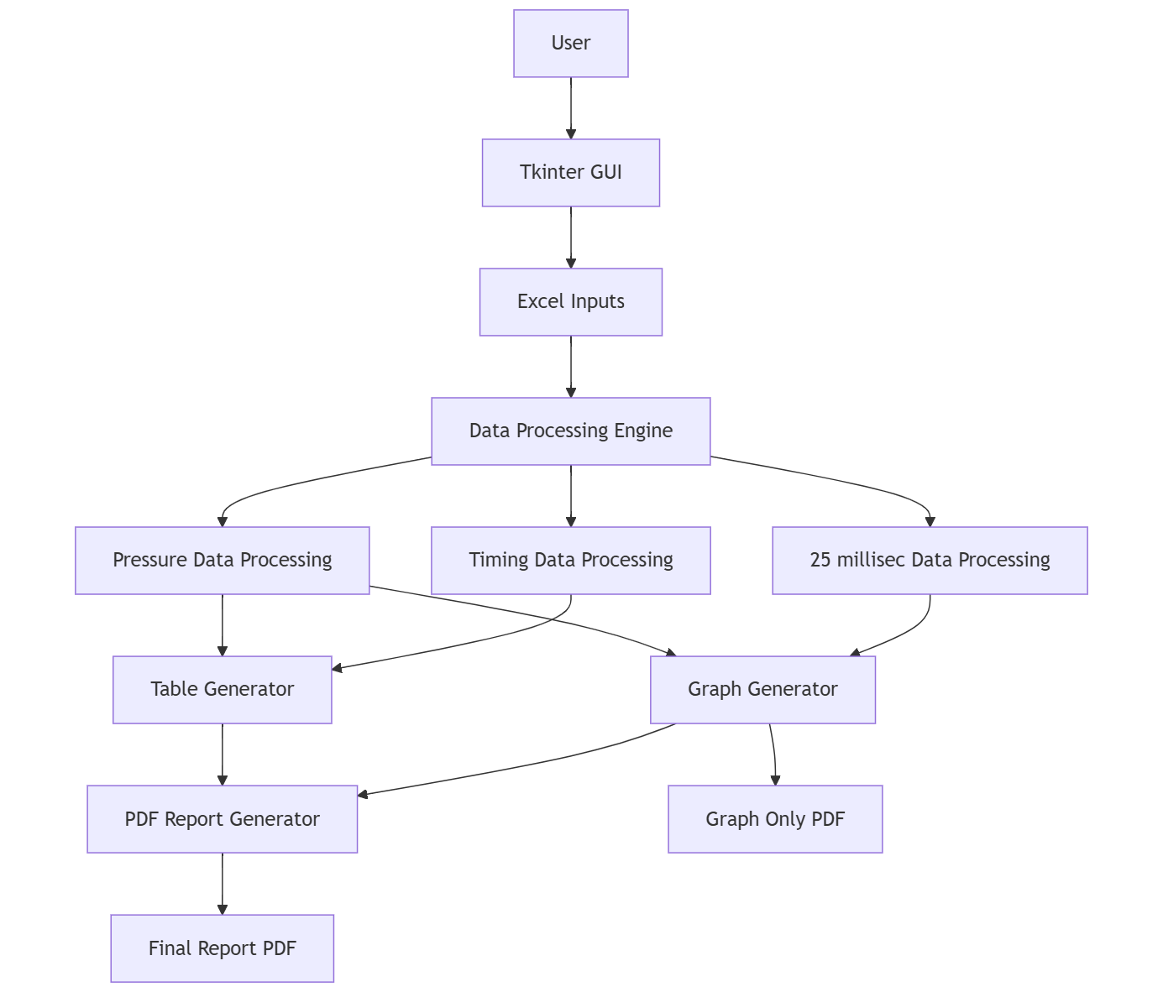
The system follows a modular layered architecture consisting of the following components:
Data Acquisition Layer
Handles ingestion of spreadsheet-based telemetry datasets including pressure data, timing data, and actuator position measurements.
Preprocessing Layer
Performs data normalization, timestamp extraction, column validation, and missing value handling to ensure consistent data representation.
Temporal Processing Engine
Reconstructs mission timelines through countdown conversion and time-offset computation relative to launch events.
Analytical Engine
Performs subsystem evaluation including accumulator charging analysis, pressure behaviour assessment, and actuator motion characterization.
Visualization Module
Generates graphical representations of pressure variations and mechanical motion trajectories.
Report Generation Module
Produces structured technical documentation containing performance metrics, tables, and graphical outputs.

GSLV (MARK-2) SYSTEM ANALYSIS
The GSLV Mark-2 implementation focuses on evaluation of cryogenic subsystem behaviour specific to its ground support configuration. The system processes telemetry corresponding to accumulator charging cycles, pressure variations, and cryogenic arm retraction events.
Temporal reconstruction of charging sequences enables identification of pressure transitions and recharge behaviour of accumulators. Pressure measurements associated with liquid oxygen and liquid hydrogen subsystems are evaluated to determine operational stability.
The framework performs event-driven extraction of subsystem parameters at predefined mission intervals, enabling systematic validation of cryogenic ground operations associated with the Mark-2 configuration.

LVM3 (MARK-3) SYSTEM ANALYSIS
The LVM3 implementation extends the analytical framework to support advanced cryogenic subsystem configurations. The system processes high-frequency telemetry streams including pressure measurements, timing data, and actuator position signals.
Accumulator charging characteristics are reconstructed through time-aligned pressure extraction, enabling evaluation of subsystem performance during pre-launch operations. Cryogenic arm retraction dynamics are analyzed through actuator motion tracking and milestone detection.
The implementation supports automated generation of engineering reports describing subsystem behaviour, pressure characteristics, and actuator response patterns.

CHAPTER 7

7.1 IMPLEMENTATION
The system is implemented using a modular computational framework integrating data processing, visualization, and reporting capabilities.
Programming Environment
- Python-based computational implementation.
Data Processing
- Structured telemetry interpretation using dataframe-based processing.
- Timestamp parsing and temporal alignment operations.
User Interface
- Graphical operator interface for dataset selection and mission parameter specification.
Visualization
- Generation of pressure variation graphs and actuator motion plots for subsystem evaluation.
Report Generation
- Automated generation of structured engineering reports containing tabulated results and graphical outputs.
The implementation enables automated transformation of raw telemetry data into interpretable engineering representations.

7.2 RESULTS AND DISCUSSION
The developed framework successfully reconstructs cryogenic subsystem behaviour and enables automated evaluation of ground support system performance. The system demonstrates reliable extraction of accumulator pressure characteristics and accurate reconstruction of charging and discharging cycles.
Pressure visualization reveals dynamic behaviour of cryogenic subsystems during operational phases, while actuator motion analysis provides quantitative assessment of cryogenic arm retraction characteristics.
The results confirm the effectiveness of the framework in transforming large-scale telemetry datasets into structured engineering insights and improving diagnostic reliability.

CHAPTER 8
OUTPUT
USER INTERFACE
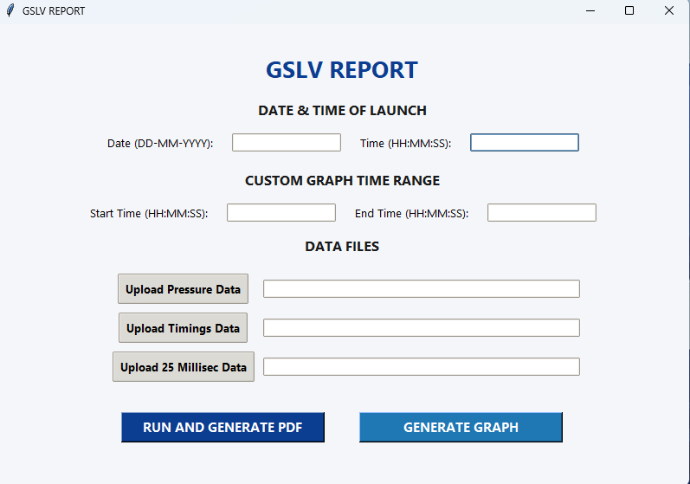
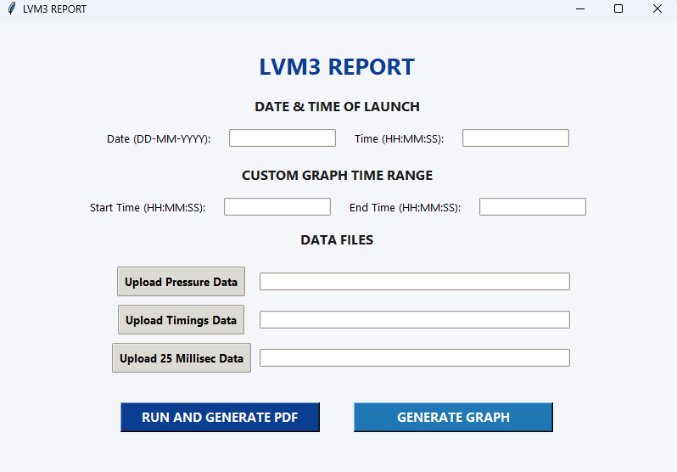
GSLV REPORT
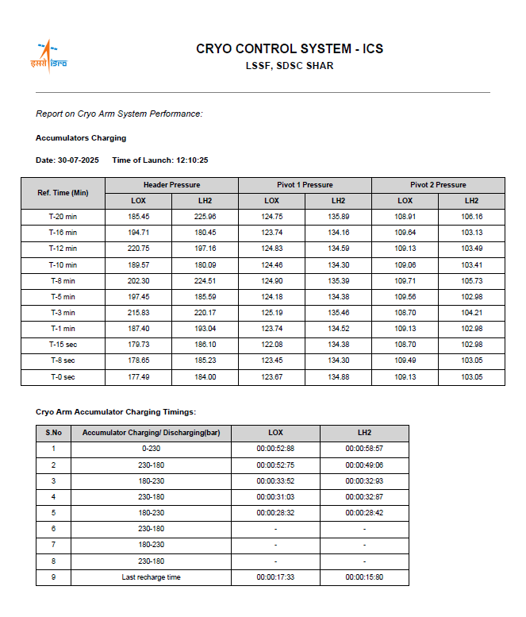
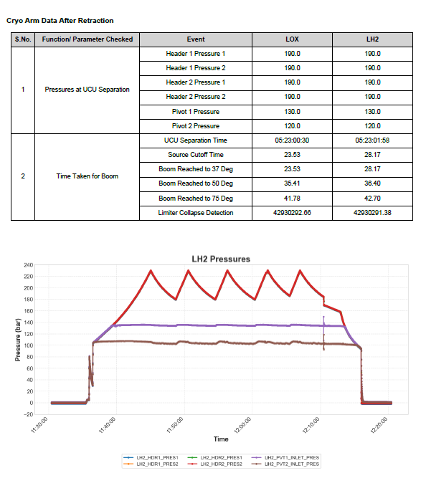

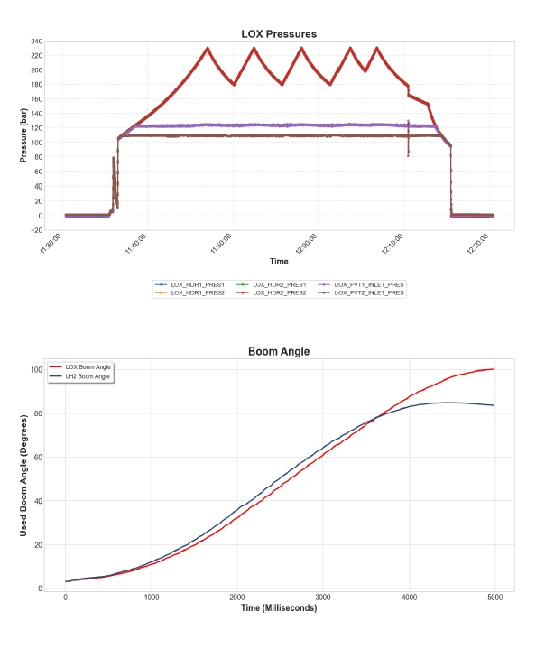

LVM3 OUTPUT
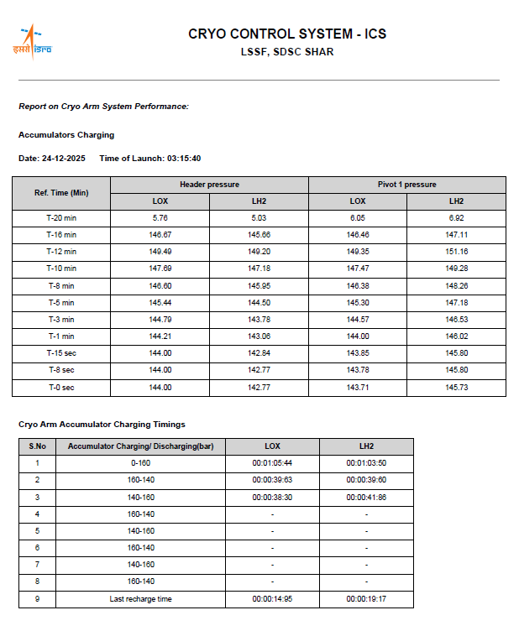
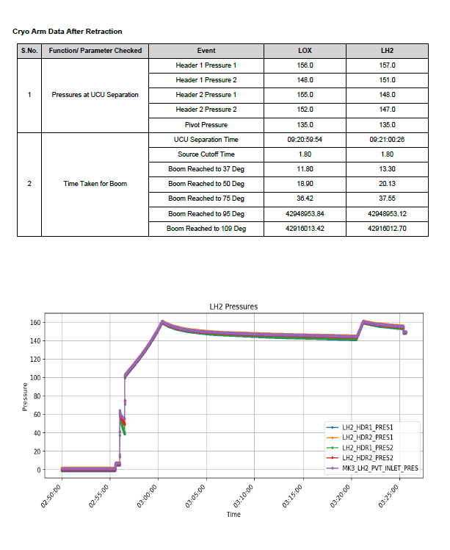
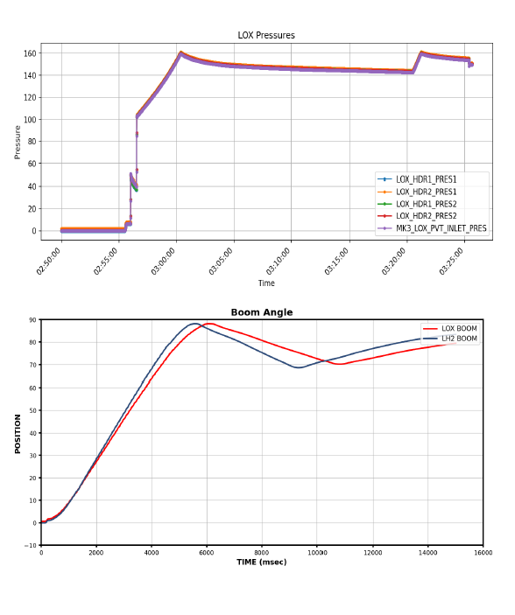

FUTURE SCOPE
The proposed framework can be extended to incorporate real-time telemetry monitoring and predictive performance evaluation of cryogenic subsystems. Integration with advanced anomaly detection algorithms can enable early identification of operational deviations.
The system may also be expanded to support additional launch vehicle configurations and incorporate machine learning models for predictive maintenance and automated fault diagnosis.
Further enhancements may include distributed telemetry processing and real-time visualization dashboards for operational monitoring.

CONCLUSION
The project successfully implements an automated framework for cryogenic telemetry interpretation and ground support system evaluation. The system enables systematic reconstruction of accumulator charging cycles, pressure behaviour analysis, and actuator motion characterization through time-synchronized data processing.
The implementation enhances reliability of cryogenic system validation, reduces manual analysis effort, and provides structured engineering representations of subsystem behaviour. The developed framework establishes a scalable foundation for advanced launch vehicle diagnostic and performance evaluation systems.

